Well Monitor Installation and Maintenance
Engineers Without Borders – San Francisco Professional Chapter
Version 0 - Updated 6/25/2022

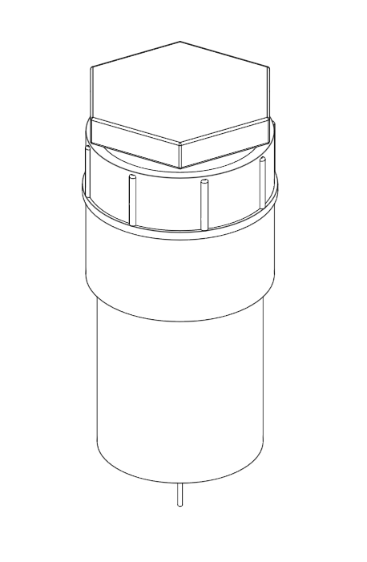

Overview
The well monitor is a tool that automatically measures and saves water level data from wells. It operates on the principle of buoyancy: a plastic pipe is suspended inside the well, and the weight of this pipe decreases as the water level increases and more of the pipe is pushed upward by the buoyant force. The well monitor is mounted at the top of the well, and only the pipe comes into contact with the water in the well. This makes maintenance and inspection simple, improves the lifetime of the device, and eliminates concerns about contaminating potable water. The well monitor takes one depth measurement every three hours, and it saves this value to a USB flash drive. It is powered by a single non-rechargeable 9V battery, which will last over a decade before needing replacement.

Installation
Proper installation of the well monitor requires information about the expected range of depths within the well. For best accuracy, the length of pipe suspended from the well monitor should just exceed the range of possible water depths, so that at the lowest water level, very little of the pipe is submerged, and at the highest water level, close to all of the pipe is submerged. However, if the water level ever falls below or rises above the pipe, the sensor will record inaccurate values.

The pipe is suspended by two cables; one is attached to the well monitor and is used for measurements, the other is loose and is only a backup to prevent the pipe from falling down the well. Cut a length of steel cable that suspends the pipe such that the bottom of the pipe is just below the lowest expected water level. Attach this cable to the top of the pipe. Feed the other end of the cable through the hole in the bottom of the well monitor and the hole in the lever, fold it back on itself, and crimp it in place with a ferrule. Glue the bottom of the well monitor Cut a slightly longer piece of steel cable and fix that separately to the pipe. Attach the other end permanently to the top of the well. Slide the bottom of the well monitor up into the PVC case and glue it in place with epoxy.

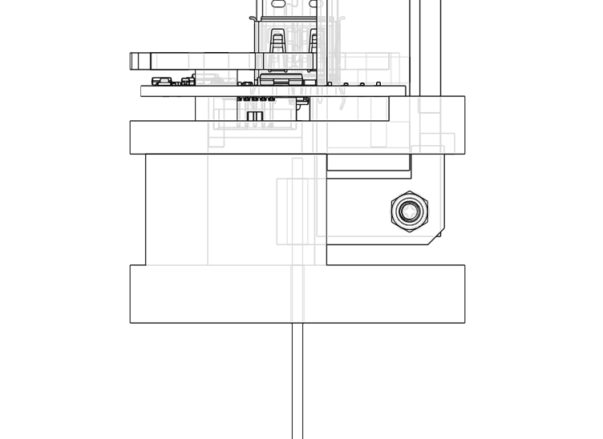

Lever

Bottom

Cable

The case for the well monitor is a 2” PVC pipe, and this can be sealed to the top of the well like any PVC pipe.
Operation
The well monitor will start to take measurements as soon as it has power. Open the well monitor by unscrewing the pipe cap. Insert a USB flash drive, then connect a new 9V battery to the 9V battery connector. Take note of the time: all measurements will be taken at 3 hour intervals starting at this time.
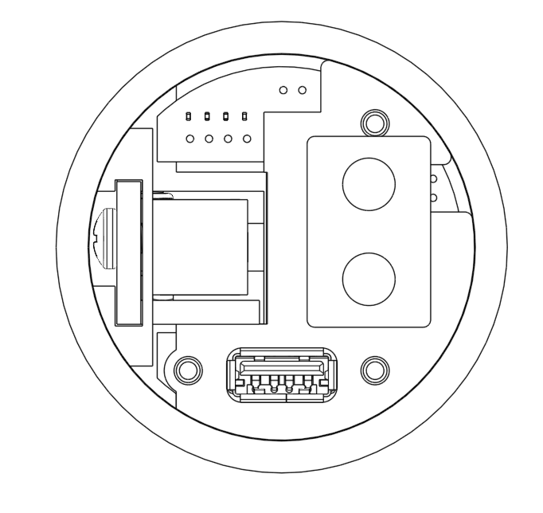

Battery

USB Flash Drive Connector

To extract the data, simply unplug the USB flash drive. Plug it in to a computer, and open welldata.txt. The file will include a column for timestamps and a column for depth measurements. Copy this file in order to keep it.

To restart the device, plug the USB flash drive back into the well monitor. The well monitor will not enter deep sleep while the USB flash drive is unplugged, so it is recommended to avoid removing the flash drive for more than a few hours at a time. The well monitor will add a line to the file to indicate that it has restarted measurements, and continue collecting data.

